**Report on Sadbhawna Diwas Celebration**

The **Department of Political Science, Himachal Pradesh University**, observed **Sadbhawna Diwas** on **20th August 2025** with great zeal and thoughtfulness. The programme aimed to spread the message of harmony, peace, and goodwill among students while reflecting upon the values espoused by former Prime Minister **Rajiv Gandhi**, in whose memory this day is commemorated.

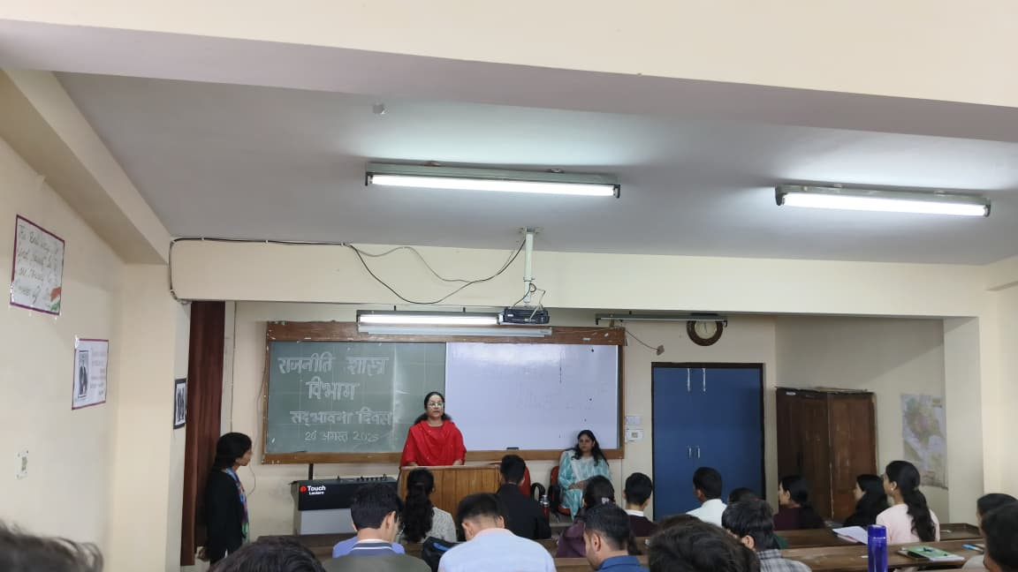

On this occasion, several students expressed their views on the importance of tolerance, unity, and communal harmony in contemporary society. Student participants **Neha Sharma, Sahil, Pawan, Meenakshi, and Vandana** shared insightful perspectives, while **Jyoti** enriched the event with a melodious song dedicated to the theme of harmony, which was warmly appreciated by all.

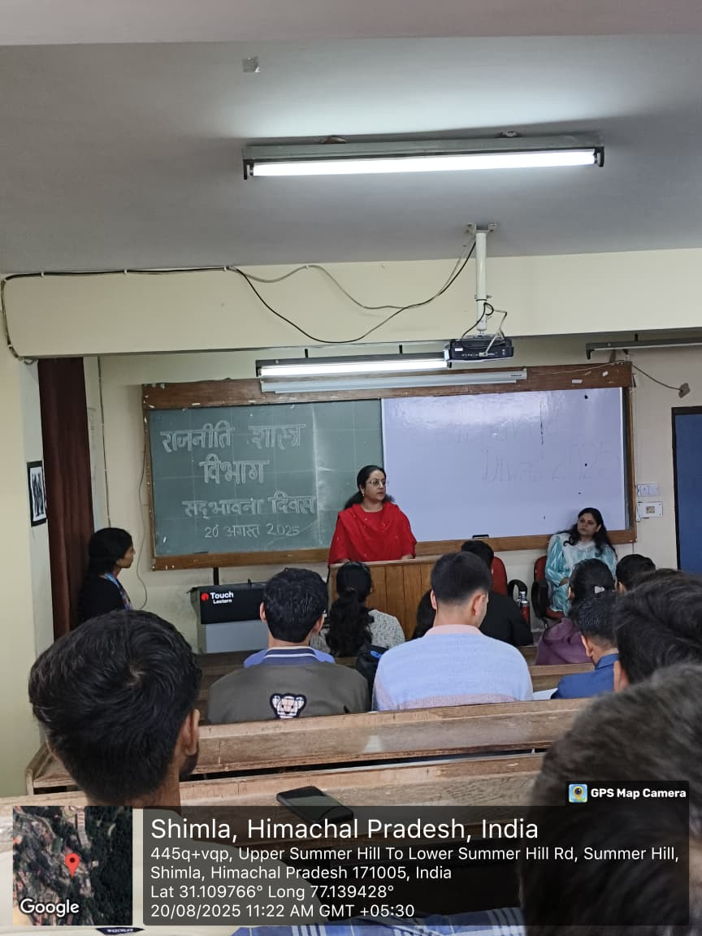

The academic leadership of the department further inspired the gathering. **Chairperson Prof. Abha Chauhan Khimta** and **Prof. Mini Pathak Dogra** addressed the participants, emphasizing the significance of Sadbhawna Diwas. They recalled Rajiv Gandhi’s vision of a progressive India built on communal harmony, national integration, and youth empowerment, highlighting its continued relevance today.

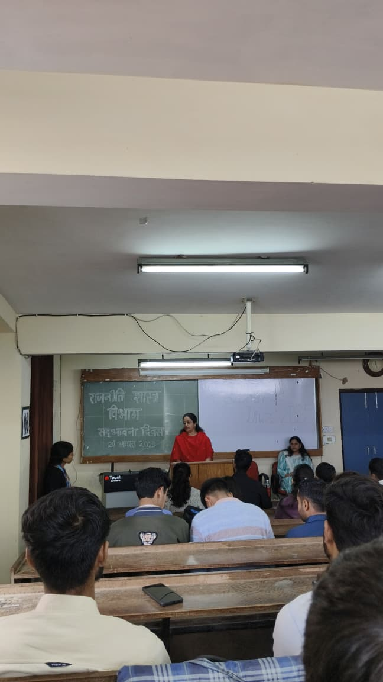

The programme was coordinated by **Kunal Bhardwaj**, who concluded the event by reminding everyone of their collective responsibility to uphold democratic values and foster peace and inclusiveness. The celebration not only paid tribute to Rajiv Gandhi’s legacy but also reinforced the timeless importance of harmony in sustaining democracy and nation-building.