**Report on Environmental Awareness Visit to Potterhill, Summerhill, Shimla**

On behalf of the **Department of Political Science**, a one-day environmental awareness visit to **Potterhill, Summerhill, Shimla** was organized for Master’s 1st and 3rd semester students along with Ph.D. research scholars on dated 13 August 2025.

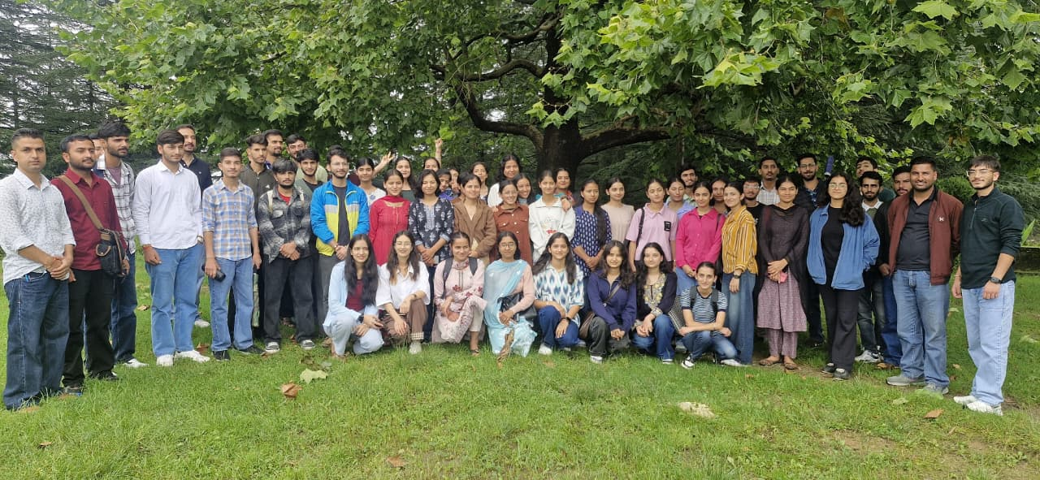

The purpose of the visit was to sensitize students towards ecological issues and to understand the significance of environmental conservation in the contemporary context.

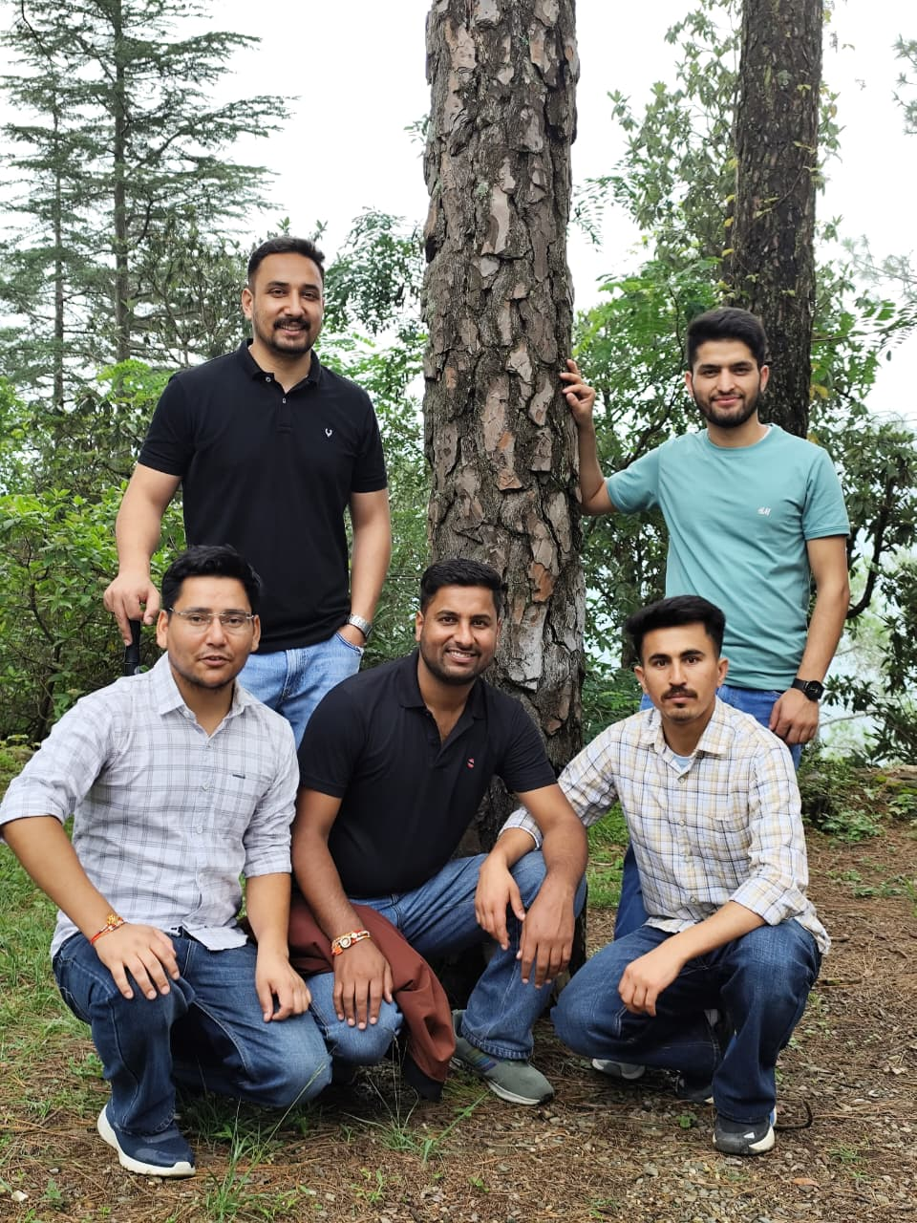

Potterhill, with its rich greenery and tall deodar and pine forests, provided a natural classroom to explore the themes of biodiversity, sustainability, and the impact of climate change on hill regions. The students and research scholars actively engaged in discussions and expressed ideas on adopting sustainable lifestyles. A short cleanliness drive was also carried out, which gave practical experience of community participation in maintaining environmental health. Such activities not only create awareness but also encourage collective responsibility.  
