**Report on Departmental Visit to Himachal Pradesh Vidhan Sabha**

On behalf of the **Department of Political Science**, a departmental visit was organized to the **Himachal Pradesh Vidhan Sabha, Shimla** on **21st August 2025**. The visit included students of Master’s 1st and 3rd semesters, Ph.D. research scholars, and was led by the respected **Chairperson Madam**.

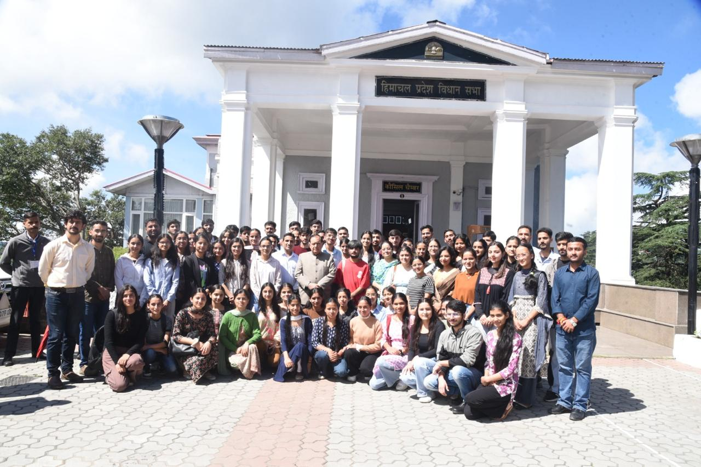

The objective of the visit was to provide students with firsthand exposure to the functioning of the legislative assembly and to deepen their understanding of parliamentary democracy. During the visit, the delegation had the privilege of an interactive session with the **Hon’ble Speaker of the Himachal Pradesh Vidhan Sabha**,

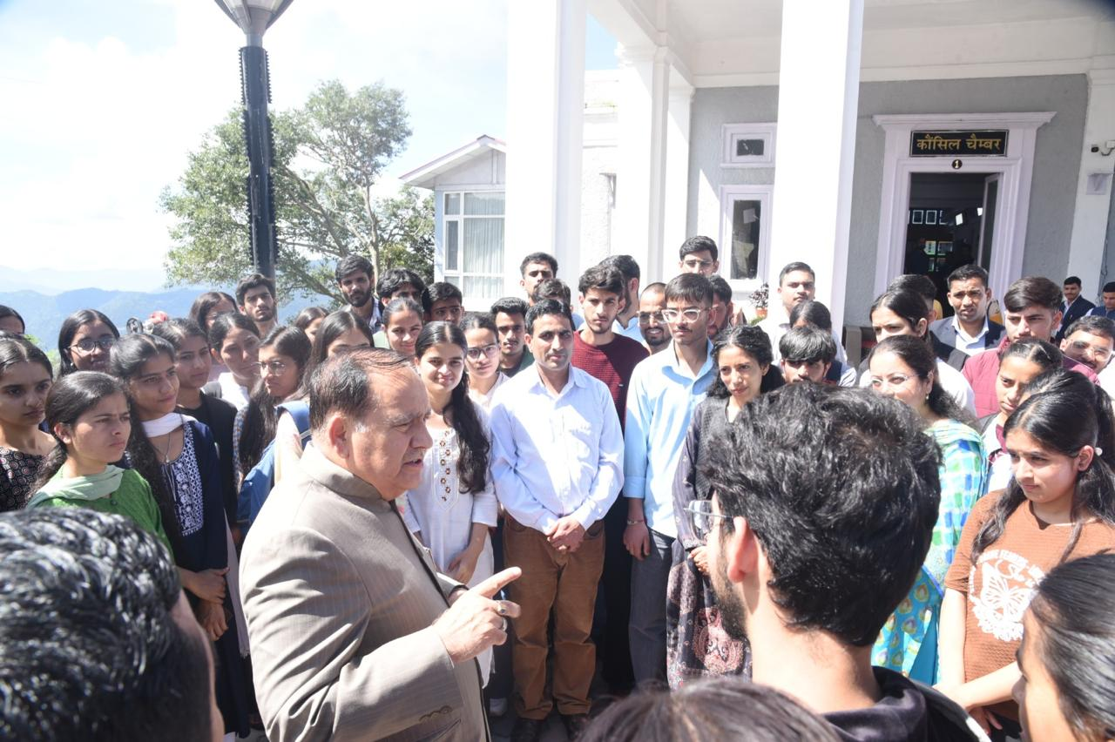

who explained the role of the Speaker, the conduct of proceedings, and the significance of legislative debates in a democracy. The interaction proved highly insightful and encouraged students to ask thought-provoking questions.

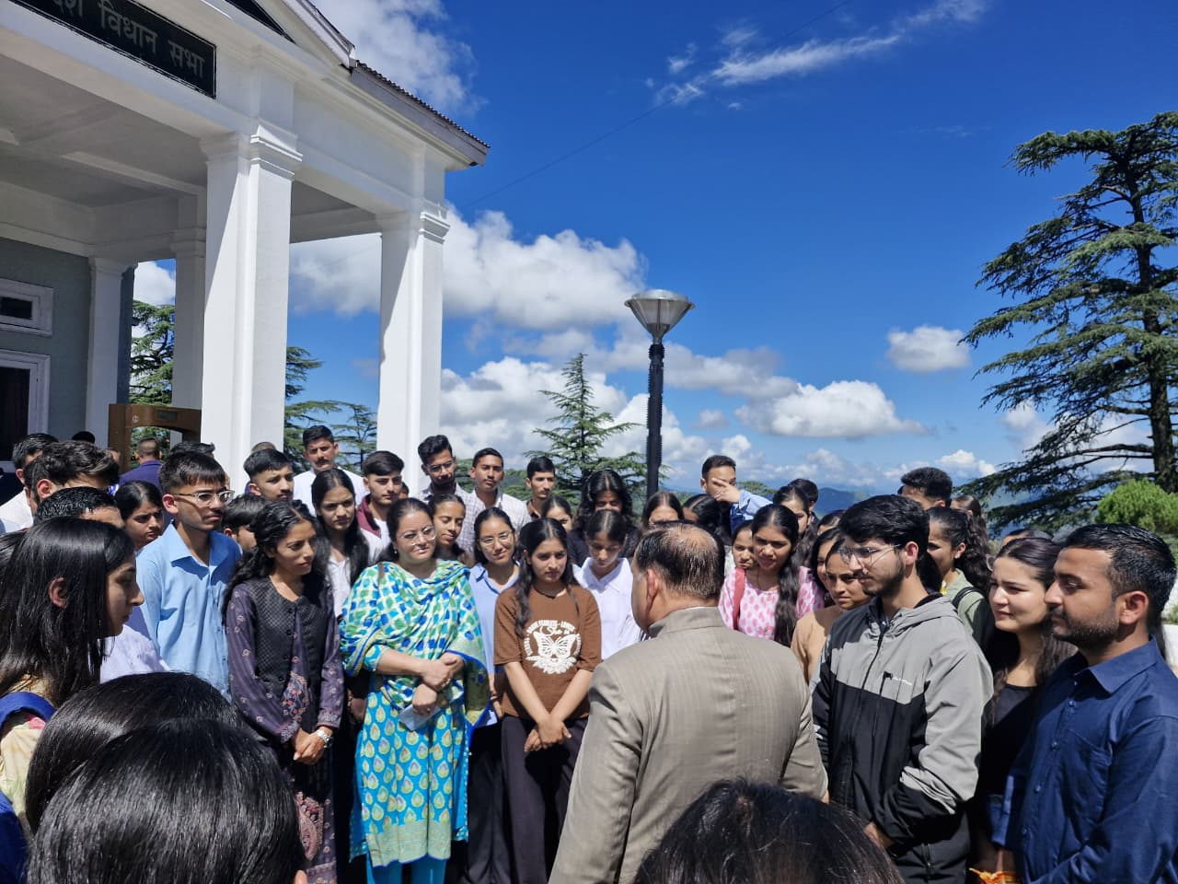

The group also attended an **assembly session**, which allowed them to closely observe legislative discussions and the manner in which policies and laws are debated and framed. This real-time exposure complemented classroom learning and broadened the students’ perspectives on governance, policy-making, and political processes.

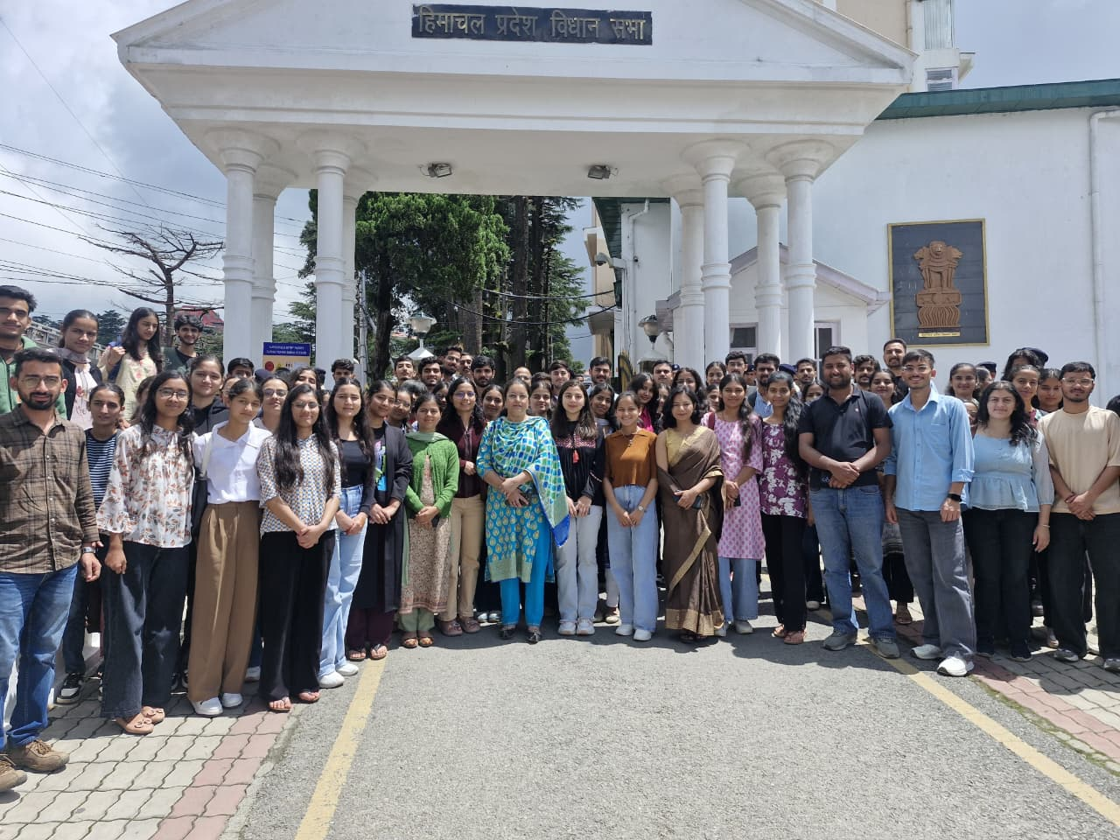

The visit was a highly enriching experience for the Master’s students and research scholars. It successfully combined academic learning with practical understanding, leaving all participants inspired to engage more deeply with democratic institutions.