**Political Ideas in the Ramayana and Ancient India**

On **8th September 2025**, the Department of Political Science, Himachal Pradesh University, organized an enlightening **guest lecture** on **"Political Ideas in the Ramayana and Ancient India"**. The event featured **Professor Samptoor Ranganath**, a distinguished scholar in political thought, as the guest speaker. The **guest lecture** aimed to explore how ancient Indian epics and texts offer profound insights into governance, ethics, and political philosophy.

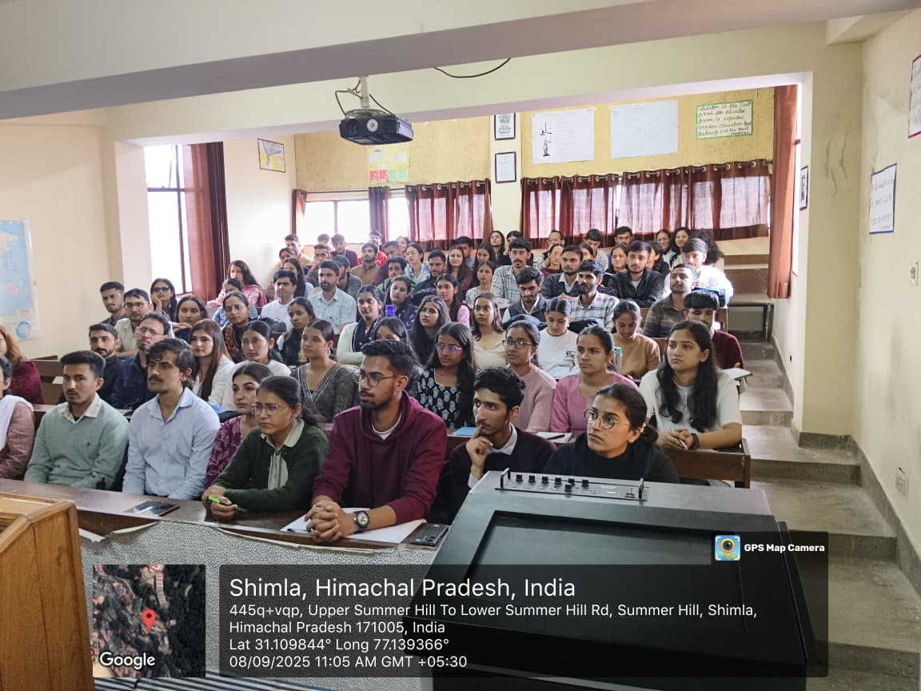

The program began with a warm **welcome speech by Chairperson Dr. Abha Chauhan Khimta**, who highlighted the importance of understanding ancient political ideas in the context of modern governance. She emphasized the department's continuous efforts to promote critical thinking and academic inquiry among students.

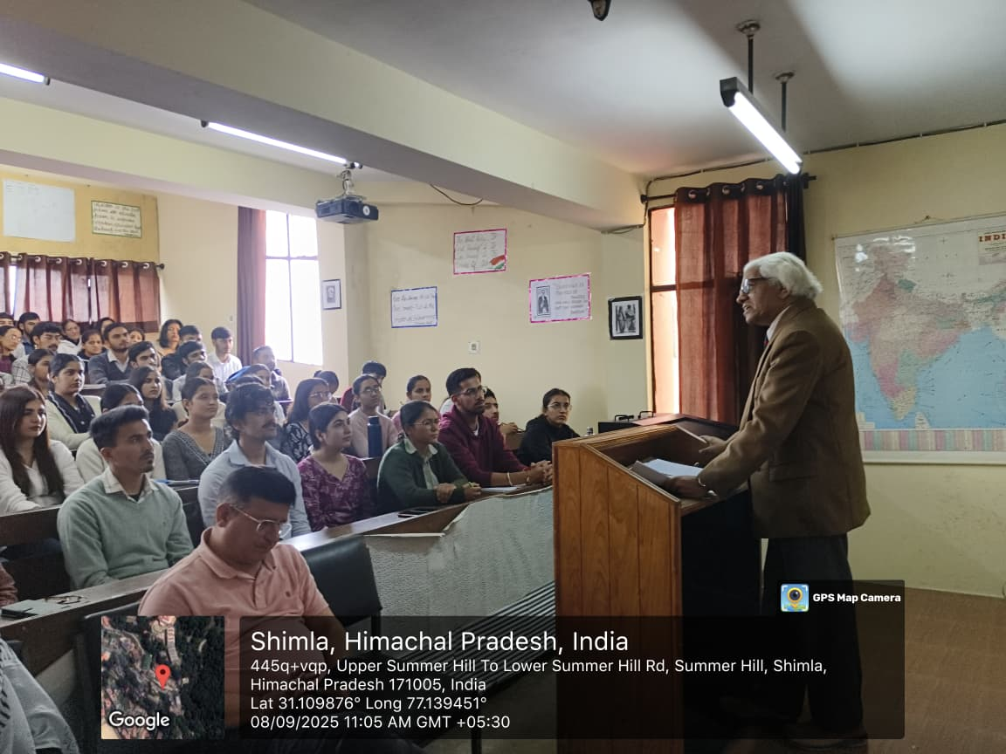

Professor Ranganath explained that the *Ramayana* is not just a religious epic but also a guide to political values. He elaborated on the concept of **Dharma**, showing how Lord Rama’s life exemplifies the duties and responsibilities of a just ruler. The idea of **Rajdharma**—the king’s obligation to uphold righteousness and serve the people—was discussed as central to ancient Indian political thought. The role of wise advisors and consultative decision-making processes was also highlighted.

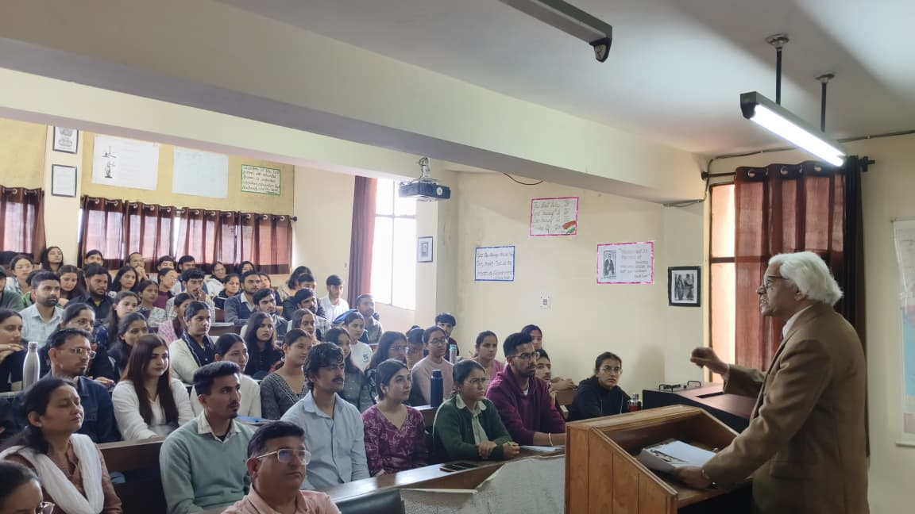

In addition to the *Ramayana*, the lecture covered the **Arthashastra of Kautilya** and **Manusmriti**, focusing on ancient approaches to statecraft, law, and social order. The session concluded by relating these age-old ideas to modern politics, suggesting that the principles of ethical leadership and people-centric governance remain highly relevant today. The interactive session that followed demonstrated strong student engagement and thoughtful discourse.

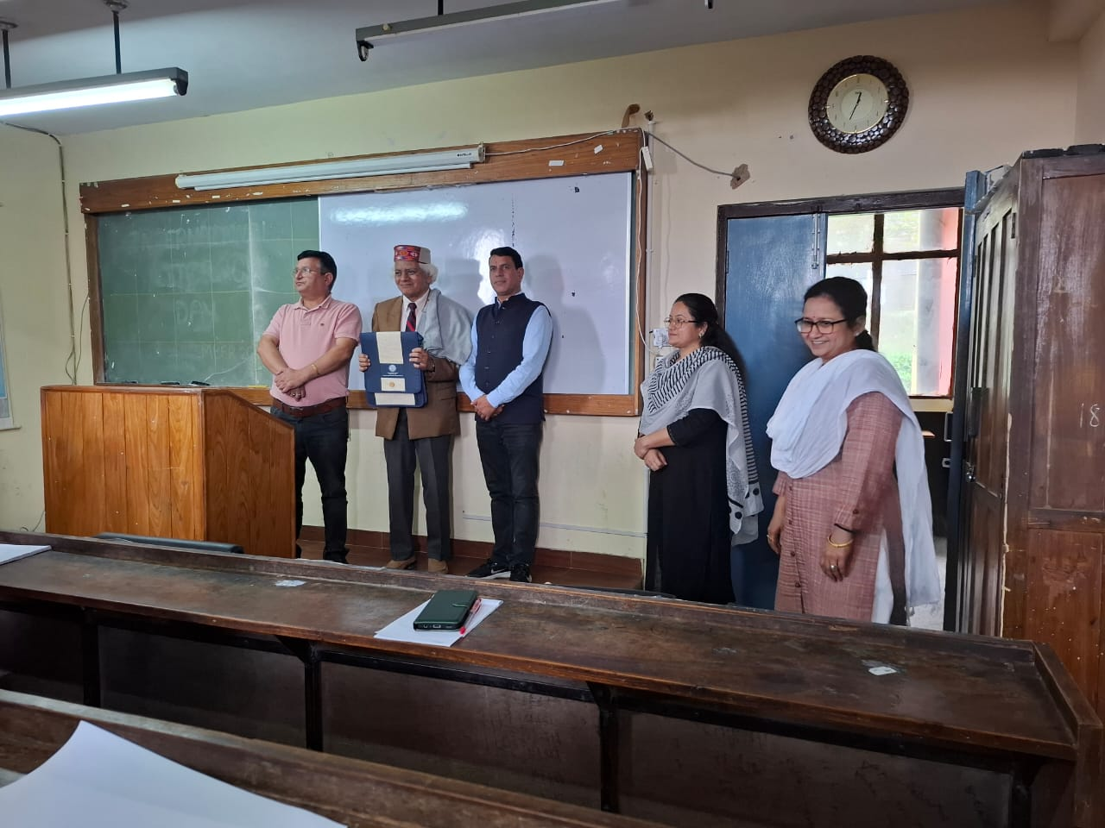

The event concluded with a **vote of thanks by Dr. Bhawna Sharma**, who expressed gratitude to Professor Samptoor Ranganath for his valuable insights and to all participants for making the lecture a success.