**THE EDGE AGES (TEA)**

**A MONTHLY NEWSLETTER**

**OF**

**DEPARTMENT OF COMMERCE, HIMACHAL PRADESH UNIVERSITY, SHIMLA**

**ISSUE-21 01.08.2025 to 31.08.2025**

**Aims and Objectives:**

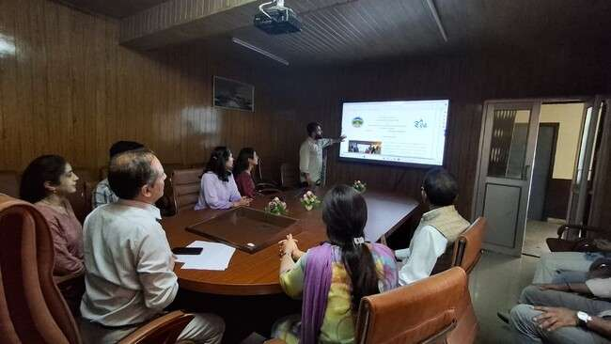The Edge Ages (TEA) is a monthly Online Newsletter of the Department of Commerce, Himachal Pradesh University, Shimla. Initially, fortnightly Online Newsletter, THE EDGE AGES (TEA) was started by the department w.e.f. 1.8.2024. The E-Newsletter has successfully completed one year of online publication. It is to focus on academic and other perspectives useful for students and readers especially for commerce and business. The Newsletter updates the activities of the Department of Commerce, Himachal Pradesh University is meant for enriching knowledge and encouraging young and enthusiastic students and researchers to contribute their original write-ups as well as to convey update information which is useful for synergizing knowledge in the field of commerce and is the effort in the benefit of all stakeholders and for welfare of the future generations. The information and write-ups can be considered for publication if are ensuring originality and recommendations of the reviewers including editorial board.

**Editorial Board:**

**Chief Editor:**

* Dr. Devinder Sharma, Professor & Chairman, Department of Commerce, H.P. University, Shimla.

**Managing Editor:**

* Dr. Raj Kumar Singh, Professor, Department of Commerce, H.P. University, Shimla.

**Advisory Committee**:

* + - Professor Vijay Kumar Sharma
    - Professor Kulbhushan Chandel

**Editorial Board**

1. Dr. Manoj Sharma, Assistant Professor, Department of Commerce, H.P. University, Shimla.
2. Dr. Vijeta Sharma, Assistant Professor, Department of Commerce, H.P. University, Shimla.
3. Ashish (Research Scholar)
4. Aditi Sharma (Research Scholar)
5. Palak Sidhu (Research Scholar)
6. Alisha Sharma (Research Scholar)

**Web Management Board**

* Web Manager: Shashi Dogra, Web In-Charge, Computer Center, Himachal Pradesh University, Shimla.
* Web Management Board (Scholars)

1. Ashish (Research Scholar)
2. Vishal Kaushal (Research Scholar)
3. Sunil Kumar (Research Scholar)
4. Satish Kumar (Research Scholar)
5. Tarun Sharma (Research Scholar)

**Photography In-Charge (Scholars and Students)**

1. Paramjeet (Research Scholar)
2. Tarini Kanwar (Research Scholar)

**मुख्य संपादक का संदेश**

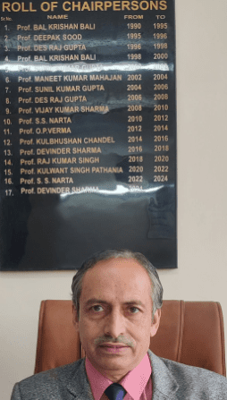हिमाचल प्रदेश विश्वविद्यालय के वाणिज्य विभाग की मासिक न्यूज़लेटर द एज एजेज़ (TEA) को एक वर्ष पूर्ण हुआ है । **न्यूज़लेटर के 21वें अंक** का सफलतापूर्वक प्रकाशन कर दिया गया है, जो हमारे **संपादकीय एवं वेब प्रबंधन टीम** की निष्ठा, तथा **फोटोग्राफी टीम** के सहयोग का परिणाम है।

यह अंक भी पूर्व अंकों की तरह **शैक्षणिक गतिविधियों, अनुसंधान संबंधी समाचारों, विभागीय उपलब्धियों**, और वाणिज्य विषय के विद्यार्थियों व युवा पेशेवरों के लिए **रोज़गार व अनुभव के अवसरों** की समृद्ध जानकारी प्रस्तुत करता है। साथ ही यह **शैक्षणिक संवाद और सीखने** का एक प्रभावशाली मंच भी प्रदान करता है।

मैं उन सभी व्यक्तियों को **हार्दिक बधाई और धन्यवाद** देना चाहता हूँ, जिनके सक्रिय योगदान और समर्पण से इस अंक का प्रकाशन संभव हो पाया। आपका यह योगदान हमारे पाठकों को निरंतर ज्ञानवर्धक सामग्री प्रदान कर रहा है।

मुझे विश्वास है कि TEA के मासिक अंकों का यह **संग्रह**, वाणिज्य विभाग के प्रयासों को भविष्य की पीढ़ियों के समक्ष उजागर करेगा और उन्हें प्रेरणा प्रदान करेगा।

शुभकामनाओं सहित,

**प्रोफेसर देविंदर शर्मा**  
मुख्य संपादक, द एज एजेज़  
विभागाध्यक्ष, वाणिज्य विभाग  
हिमाचल प्रदेश विश्वविद्यालय

**प्रबंध संपादक की कलम से**

प्रिय छात्रगण, संकाय सदस्यगण एवं पाठकगण,

सदैव की भांति मै पुनः नए क्रमांक क़े सफलतापूर्वक प्रकाशन की शुभकामनाऍ देता हूँ । हमे नहीं भूलना है की युवा मनों और उनके चरित्र के निर्माण में मूल्यों की बुद्धिमत्ता (Value Wisdom) का अत्यंत महत्व है। हिमाचल प्रदेश विश्वविद्यालय के वाणिज्य विभाग द्वारा यह सतत प्रयास किया जा रहा है कि छात्रों में जीवन मूल्यों को आत्मसात कराया जाए, जिससे वे समाज में सकारात्मक परिवर्तन ला सकें।

मुझे यह बताते हुए अत्यंत प्रसन्नता हो रही है कि हमारा विभाग निरंतर शिक्षा के क्षेत्र में उत्कृष्टता प्राप्त करने हेतु प्रयासरत है और इसके नवीनतम उपलब्धियों एवं प्रगति को आपके साथ साझा कर रहा हूँ।

मैं आप सभी से आग्रह करता हूँ कि आप अपने दैनिक जीवन में प्रेम, सम्मान, अहिंसा, सत्यनिष्ठा, धैर्य और क्षमा जैसे मूल्यों को अपनाएँ और संस्थान तथा समाज में एक सुंदर, आनंदमय एवं शांतिपूर्ण वातावरण का निर्माण करें। में पत्रिका के एक वर्ष पूर्ण होने की बधाई देता हूँ और अपेक्षा करता हूँ की छात्र इस पत्रिका को पढ़ कर ज्ञान अर्जित करेंगे व् वाणिज्य विभाग की गतिविधियों से अवगत होंगे ।

सादर,  
**प्रोफेसर राज कुमार सिंह**  
**प्रबंध संपादक**

**विद्यार्थी एवं शोधार्थी संपादकीय बोर्ड का संदेश**

इस मासिक समाचार पत्रिका के इस अंक में हम अपने सभी पाठकों और लेख प्रेषकों के प्रति हार्दिक आभार व्यक्त करना चाहते हैं। आप सभी की सहभागिता, प्रोत्साहन, रचनात्मक सुझाव और निरंतर प्रेरणा ही हमारी ऊर्जा को समन्वित करती है और हमें वाणिज्य विभाग की प्रत्येक गतिविधि से आपको अवगत कराने हेतु सक्रिय बनाए रखती है।

हमारी टीम सदैव तत्पर रहती है और पूरी मेहनत के साथ कार्य कर रही है ताकि आप तक विभाग की गतिविधियों की जानकारी समय पर पहुँचे। हमें आशा है कि आपको इस अंक की प्रस्तुति पसंद आएगी। साथ ही हम आपके बहुमूल्य सुझावों और उत्साहवर्धन की प्रतीक्षा करते हैं।

**शोधार्थी एवं विद्यार्थी संपादकीय, फोटोग्राफी एवं वेब टीम**

**OUR MOTTO**

Spread knowledge, excel and prove dynamic potential in the sphere of different sectors as experts dealing commerce by refreshing The Edge Ages of commerce updates.

**HIMACHAL PRADESH UNIVERSITY**

**(NAAC Accredited ‘A’ Grade University)**

**Department of Commerce, Shimla-5**

**ACADEMIC CALENDAR FOR THE SEMESTER W.E.F. July 1, 2025 TO December-31, 2025**

|  |  |  |  |  |
| --- | --- | --- | --- | --- |
| **Month** | **Dates From- To** | **Teaching Days** | **Celebrations** | **Additional Celebrations subject to funds provided by the University** |
| **July** | 1.7.25 to 20.7.25 | Admission Process | - | * Skill Learning on Stocks/ GST/Tax etc. * Conversation with Women Entrepreneurs * Workshop on Research Methodology * Trade Fair * Plantation & Clean Environment |
| 21.7.25 to 31.7.25 | 10 | 21.7.25- Induction Programme |
| **August** | 1.8.25 to 31.8.25 | 23 | 7.8.25- National Handloom Day  26.8.25- Women Equity Day with International Day for Elimination of Violence Against Women of dated 25.11.25  31.8.25- National Unity Day |
| **September** | 1.9.25 to 30.9.25 | 25 | 5.9.25- Teachers Day with World Teachers Day of 5.10.25  14.9.25- Hindi Diwas  18.9.25- World Bamboo Day with World Environment Health Day of 26.9.25 |
| **October** | 1.10.25 to 31.10.25 | 22 | 2.10.25- International Day for Non-Violence  15.10.25- World Students Day with World Statistics Day of 20.10.25 |
| **November** | 01.11.25 to 16.11.25 | 11 | - | Students Assignments and Presentations etc. |
| **November-December** | 17.11.25 to 31.12.25 | NIL | Preparatory Days and End Semester Exams | Participation of all and Special Lecture |
| **Total Days** | | 91 |  |  |
| **Additional Academic Calendar (for Ph.D. Course Work Students and Academic Participation)** | | | | |
| They will have to attend the Viva-Voce Examination presentations of Ph.D. Scholars, give presentations on rotation basis, participate and involve in the departmental events and attend academic and research programmes. | | | | |
| Attendance of M.Com. students and Ph.D. Scholars with the approval of Chairman, in the Seminar/Workshop/Special Lecture in the Semester will be considered for Academic Attendance Count as per Norms. | | | | |
| Induction Programme will be on the first week of the start of the Semester. It will be compulsory for the students of M.Com.-1 to attend the Induction Programme. The theme of the Induction Programme will be:  **WE, THE TEAM TOWARDS EXCELLENCE OF LEARNING AND OVERALL GROWTH** | | | | |

**CHAIRMAN**

**New Session started from 28.07.2025 with the Induction Programme. The theme of the Induction Programme was:**

**WE, THE TEAM TOWARDS EXCELLENCE OF LEARNING AND OVERALL GROWTH**

**Teaching Faculty members and Research Scholars interacted with the Incumbent students and made them aware about the academic, research and overall environment of the University. Students were convinced to share their problems and were ensured cooperation and support from the entire team of the Department. The Induction Programme which started from 28.7.2025, continued till 2.8.2025.**

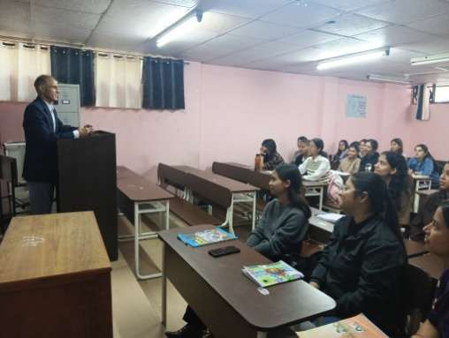 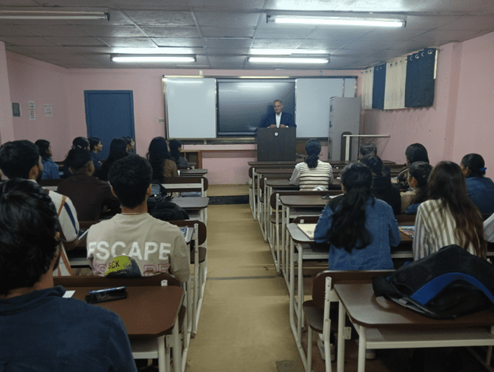

**Photos during Induction Programme on 1.8.2025 and 2.8.2025**

**ACADEMIC AND RESEARCH EXPOSURE**

**Anchal Gupta, student of Ph.D. under supervision of Professor Vijay Kumar Sharma, submitted her Thesis on 19.8.2025 for evaluation.**

**Ranju, student of Ph.D. under supervision of Professor Kuldeep Kumar Attri, submitted her Thesis on 19.8.2025 for evaluation.**

**MEETINGS:**

Meeting of Chairman with the PH.D. Research Scholars was held on 3.8.2025 to discuss issues of the research scholars.

Meeting of the Standing Committee was held on 12.08.2025 under the Chairmanship of Dean, Faculty of Commerce & Management, Professor Jai Singh Parmar. Admission of Five Ph.D. students for the Session 2024-25 has been made in the meeting apart from other decisions taken.

Meeting of the Department Council of Commerce was held on 20.8.2025 at 11.30 A.M. in the room of Chairman to discuss the issues and initiatives for qualitative delivery of academic, research and other activities.

**CELEBRATIONS/EVENTS**

National Handloom Day was celebrated by the Department on 7.08.2025. Special presentations were given on the concept by Research Scholars and Chairman address all present in the event. 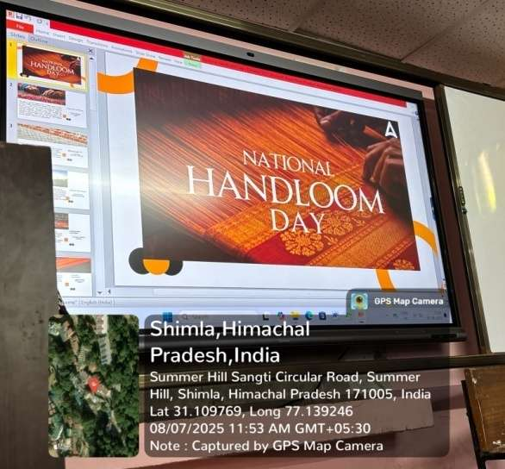 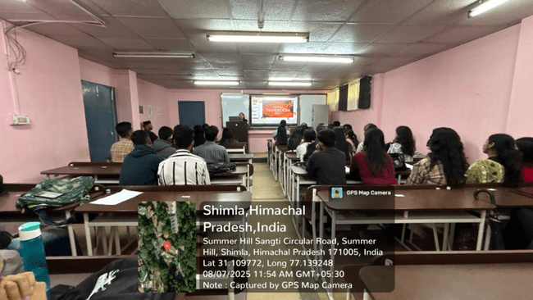

Photos of National Handloom Day

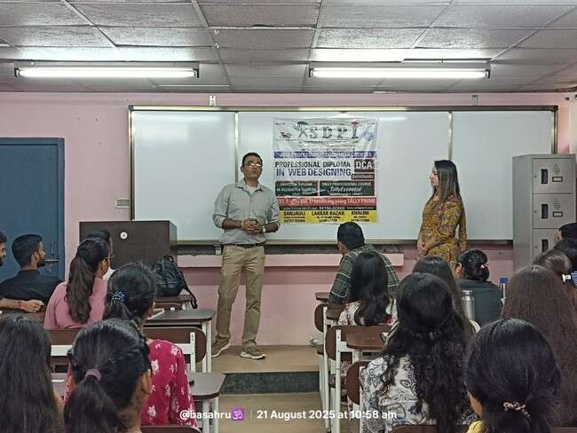

Photo of Special Lecture was delivered by XSDPI, Shimla on GST and Tally to the students on M.Com on 21.08.2025. Coordinator, Dr. Manoj Sharma held interaction with the executives of the organization.

Plantation Drive was organized by Department of Commerce on 23.08.2025. Chairman, Professor Vijay Kumar Sharma and Dr. Manoj Sharma organized the programme with the committee of Research Scholars and students of M.COM. To manage the event, Nitesh Singta and Ajay Kumar, students of M.Com. 3rd Semester were assigned the duty to manage as overall in-charges. The group consisting of 60 members including research scholars, M.Com students and three teach teaching faculty In-charges, visited Majheedi-Basantpur forest area on 23.08.2025 and planted different varieties of plants in the area. The Block Forest Officer, Panchayat Pradhan, Ward member of Basantpur and other wards also witnessed their present to encourage the group.

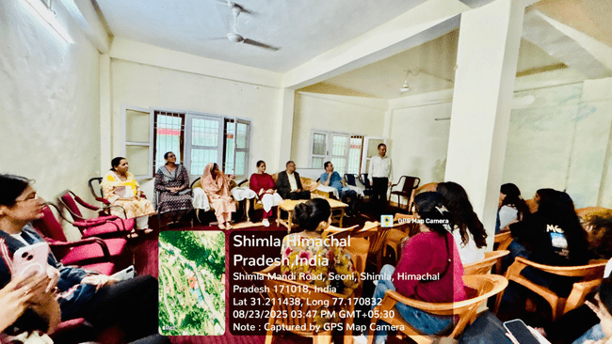 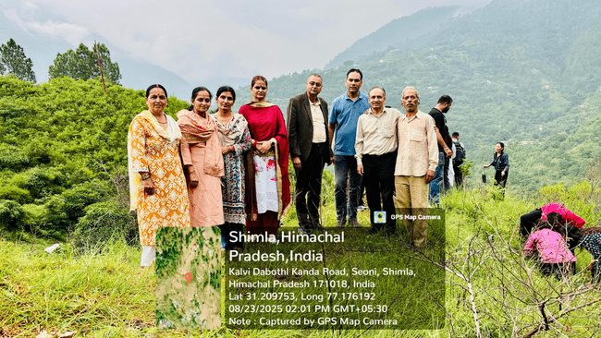

On 26.08.2025, Women Equity Day with International Day for Elimination of Violence Against Women of dated 25.11.25 were celebrated in the Department

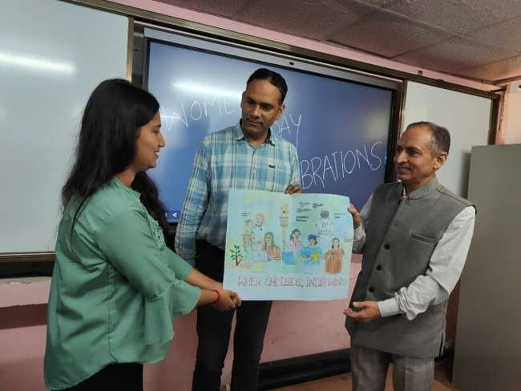 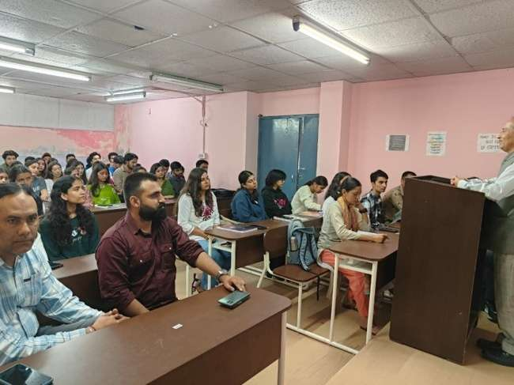

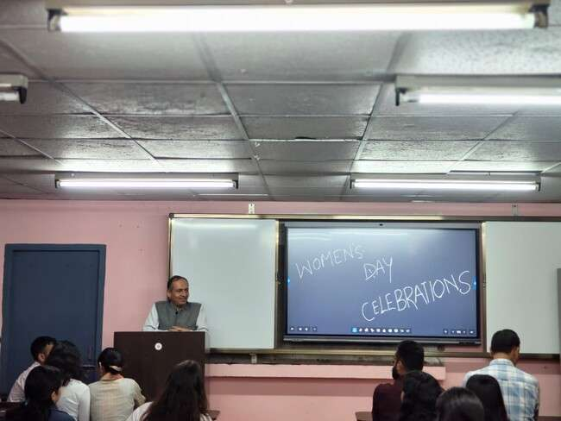

On 31.8.25- National Unity Day was celebrated. Research Scholars of the Department of Commerce addressed through their presentations on the occasion.

**ACADEMIC-RESEARCH ASSIGNMENTS**

Teaching Faculty members represented as Resource Persons in the Conferences and workshops. Viva-Voce examinations of M.Com. were taken by the teachers of the Department in the affiliated private and Govt. Colleges of Himachal Pradesh University where M.Com. is running. They attended duties of the other universities including Viva-Voce examination, Board Meetings, Resource Persons etc. and have performed inspection duties.

**EDITORIAL LEARNING**

The Stats Speak: Following the Crowd Isn't Always Smart

The stock market provides a fertile ground for observing herd behavior. Research indicates that during times of market stress, correlation among stocks increases, meaning they tend to move together more than usual. This phenomenon was starkly evident during the 2008 financial crisis. According to a study by the National Bureau of Economic Research, stocks in the S&P 500 had an average correlation of 0.74 during the crisis, compared to just 0.44 in calmer times.

But does following the herd always pay off? Not necessarily. Consider the dot-com bubble of the late 1990s. Investors flocked to tech stocks, inflating their prices to unsustainable levels. When the bubble burst in 2000, the NASDAQ Composite, which had risen five-fold from 1995 to 2000, plummeted by nearly 78% by October 2002. Many who followed the herd saw their investments evaporate. These historical lessons highlight the risks of herd behavior, reminding us that blindly following the crowd can lead to significant financial losses

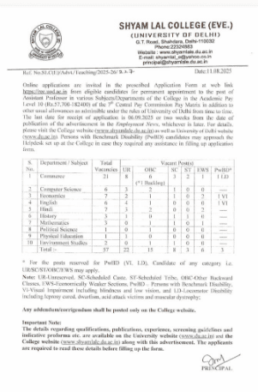

<file:///C:/Users/Commerce/Downloads/689dbf30b53a8PRCpost%20(1).pdf>

Posts in Himachal Pradesh University- Check through the link

**It’s the beginning to update……..**